|  |  |
| --- | --- |
| Date | 12 october 2022 |
| Team ID | PNT2022TMID36188 |
| Project Name | IOT based Smart Crop Protection For Agriculture |
| Maximum Marks | 2 Marks |

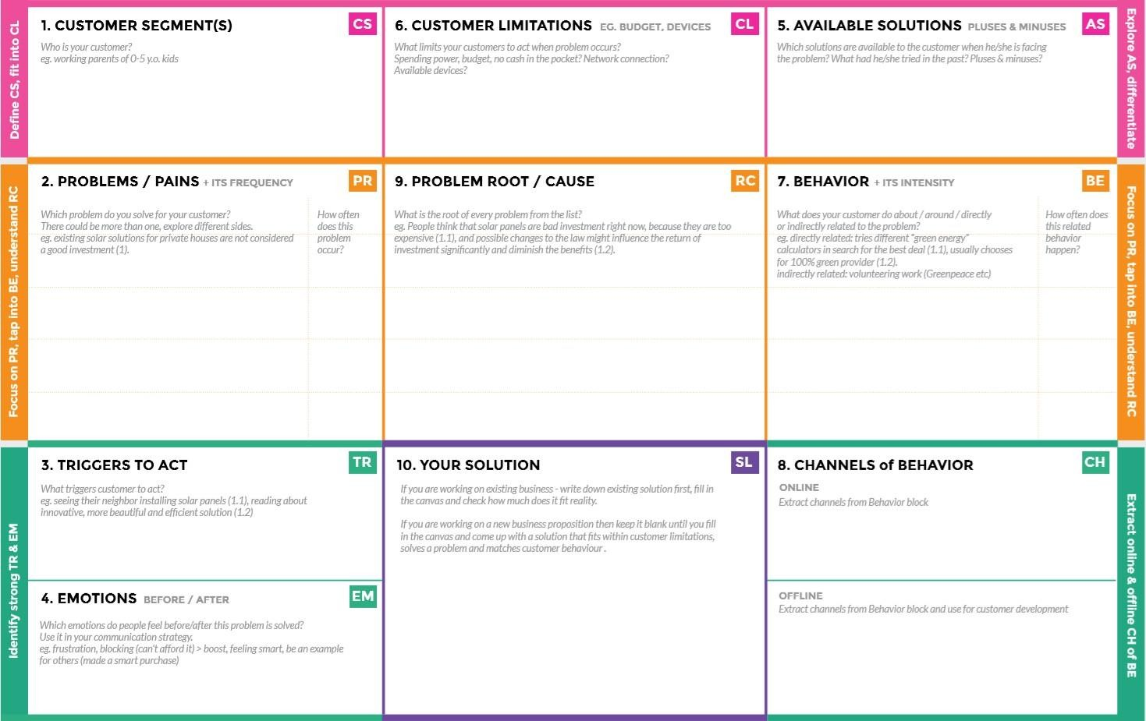





Directly associated: Farmers made

Electric fences to fear the animals.

Indirectly associated:Involved human

labours

Electric fences were the methods already used by farmers for crop protection

Reduce a need for manual labor Increased protection crop monitoring in a remote location

Farmers enjoy using this feature Easy to access & user friendly Can monitor within remote location

Customers take ofﬂine which have knowledge on about hardware products used in it for the data secreation

Online: Customers take online services to look up a survey of real time data in their framework created for them

The crop protection system helps the farmers in protecting the crop from the animals and birds which destroy the crop. This system also helps farmers to monitor the soil moisture levels in the field and also the temperature and humidity values near the field. The motors and sprinklers in the field can be controlled using the mobile application.

Create oppoutunities to lift people out of poverty in developing nations(over 60%)

The Animals in searchof food enter the field and damage all the crops before harvesting.It affects the yield terribly

Its is difficult to monitor and control. The consumers, on the other hand, depend on the crops as it provides them with a multitude of utilities.

Farmer’s ! Who’s not near his field